Big Data Alpha Model

Presented By

* Rushab Kachhara
* Pallavi Jethwani
* Gaurav Sipani
* Rohitashva Jajoo
* Gaurav Khubchandani

**Summary**

For the project we have considered four securities in our portfolio, Walmart, PepsiCo, Advanced Micro Devices and Gold ETF. All the securities are relatively safe stock and have performed consistently good over last three years, Gold has been selected due to its high negative correlation with market along with these securities. We will be analyzing the portfolio on technical, sentimental and fundamental indicators. For sentiment we have extracted twitter data for last three weeks of September and tried to analyze any trend if exist in the market, for technical analysis we have considered MACD, RSI, and Bollinger bands to gauge momentum and volatility in the market. For fundamental factors we have analyzed EPS ratio, P/E ratio and Debt ratio.

We have considered RSI and MACD primarily because MACD can confirm that it is really time to buy or sell when RSI indicates a security is oversold or overbought. Both the indicators can give a complete technical picture of the market. Similarly, EPS and P/E ratios support each other, while EPS gives earnings per share, P/E measures the relation between its earnings and stock price. For macroeconomic factor we have considered CPI index as it best measures the performance of the economy and have high correlation with stock market performance.

For technical and fundamental analysis, we have extracted the data from 1st January 2020 to 2nd October 2020, we have extracted the tweets from 13th September to 2nd October for sentimental analysis. We have used R programming for all the analysis. We have considered Log return of the stock and ran panel regression on sentimental, fundamental and technical factors to determine the significant factors affecting the stock prices to form the trading strategy.

**Overview**

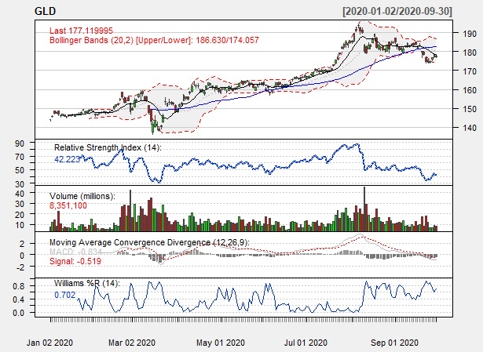**GLD (Gold ETF)**

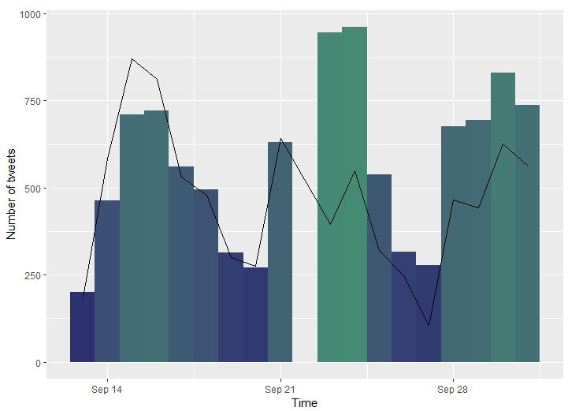With Covid disrupting the businesses across the world and stock market started declining, investors found some confidence in gold, the RSI index for gold hovered around 50-70 point mark almost throughout the year except March when lockdowns were announced, GLD crossed 70 point market on number of occasions indication it was way overbought but as market started gaining confidence around August the index started declining and currently sits at around 40, this is complimented by the fact that MACD is indicating a negative momentum from August while volume also declined for the same period. With the current volatility level in market and GLD market indicators it can be a good hedge for the portfolio. The sentiments of GLD indicate a positive trend on social media, in the last month as the GLD prices started declining, the positive trend of the tweets also started declining.

**Walmart**

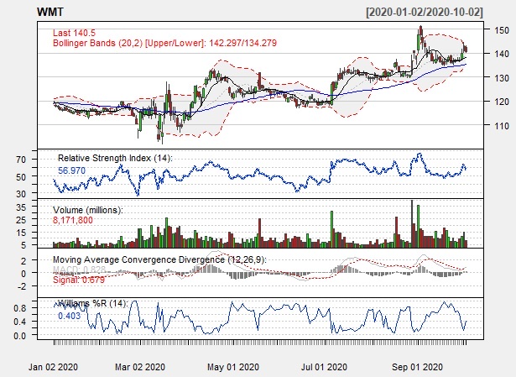Due to Covid the retail industry saw a massive growth, Walmart was one of the forefront runners to capture the increased market demand. As with most tech and retail stocks, Walmart was overbought in August, RSI crossing the 70 mark, the momentum has been positive but declining by the end of September as with most stocks in the industry. The Bollinger bands indicate volatility and the prices again are crossing the 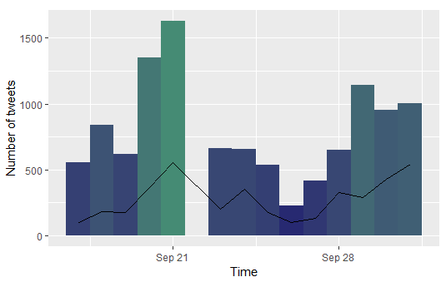2 times standard deviation on multiple occasion, which is unlike from previous years.

The Sentiment mostly has been positive throughout the September. The relationship between volume and trend has been interesting for Walmart as the number of tweets increases the positive trend also increases

**PepsiCo**

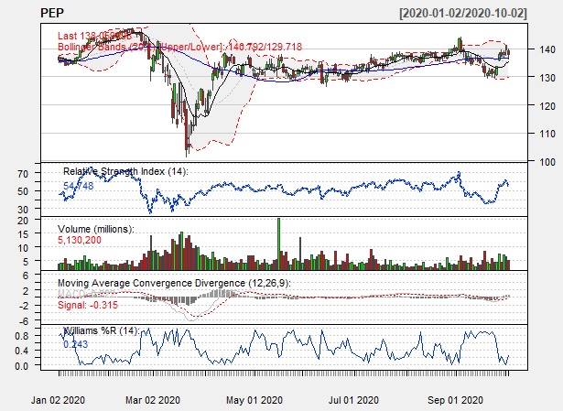PepsiCo is one of the most stable company with strong financials and consistent growth over the years. The technical indicators show the same, with the market crash in march the RSI went below 30 points but the stock quickly recovered the crash and RSI has been constant between 60 and 40 points, this is well supplemented by MACD which indicates the same as the momentum has been constant since March with little deviation. Except for the march crash the Bollinger band also indicates the normal movement of the stock.

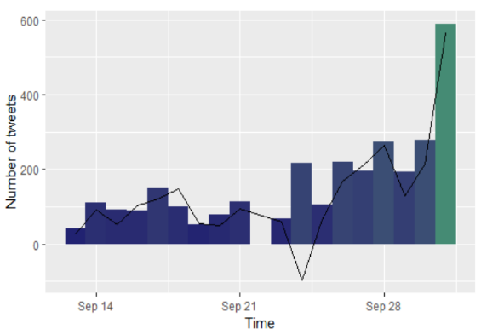The sentiment of PepsiCo has been mostly positive with a dip in third week on September, it follows the same approach as with increase in volume the positive trend increases.

**Advanced Micro Devices**

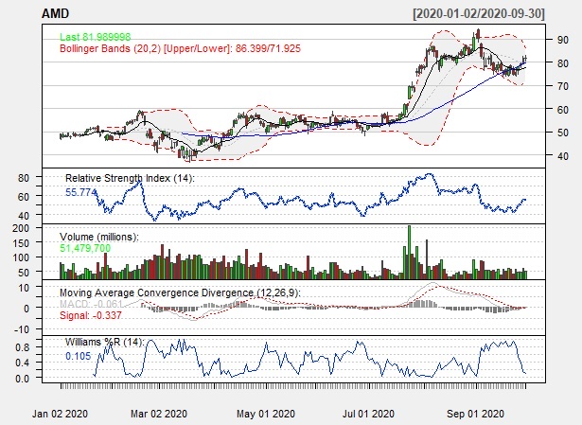As with most stocks AMD was overbought in August as the RSI crossed the 80 mark but by the end of September as market declined RSI was between 50-60 mark. MACD also indicated positive trend during the same period but declining towards the end of September like most of the stocks. Bollinger band is indicating the stock was very volatile during the whole year while crossing upper and lower band multiple times.

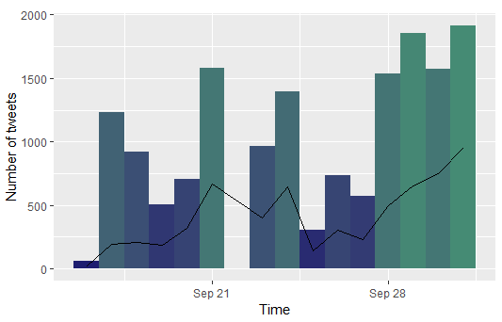The sentiment for AMD has been primarily been positive and showing upward trend with increase in tweets.

**Regression Analysis**

We have regressed the above mentioned technical, fundamental and sentimental indicators over the log returns of all the four stocks. The data was sorted into test data and training data. We have used the same data timeframe as mentioned above, the results indicate MACD, RSI and CPI index to be significant.

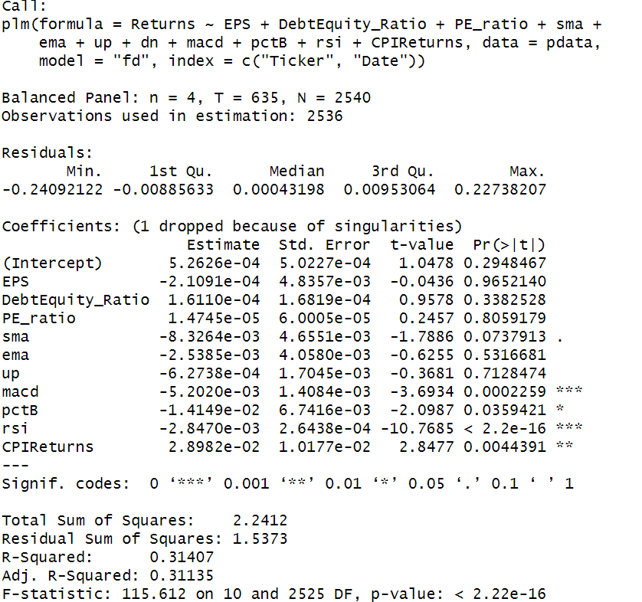

We will further regress the significant data to get beta of each factors to develop a trading strategy

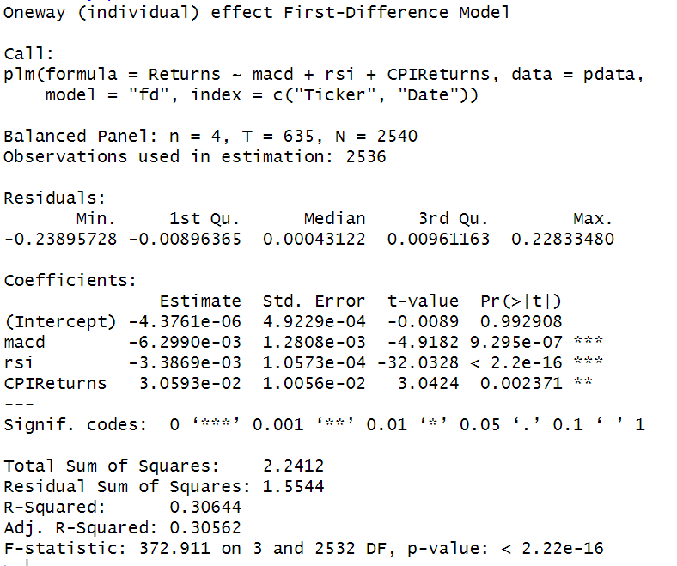

**Interpretation**

Using the regression, we can predict the daily return of each stock. We will go long on all the stocks and once investment is made; we can sum up all the returns of the stock to get the portfolio return.

MACD: For every 1 unit increase in MACD the returns of the portfolio will go down by 0.629%

RSI: For every 1 unit increase in RSI the returns of the portfolio will go down by 0.338%

CPI: for every 1 unit increase in CPI the returns of portfolio will increase by 3.05%

With our trading strategy we buy all the stocks with .399% return and 2.25% standard deviation over 285 days of test data.

